Lesson Plan Title | Holocaust – The Issue of The Past?
Name & School | Amanda Lepore - Los Angeles International Charter High School  Elizabeth Crespo - American History High School  Nikola Mitic - Vozd Karadjordje Elementary School  Vesna Kostic - Jovan Ducic Elementary School  Bashir Akinyele - Weequahic High School  Robert Koneski - Blaze Koneski Elementary school
Course | World History, Language Arts
Grade Level | High School
Total Required Time | 1 week with option to extend to a longer project.
Summary | Students will compare discrimination during the Holocaust to discrimination today. They will focus on the upstanders to try and find ways to prevent discrimination in their own communities. Then, they will share their work with a teacher in another country so other countries can learn about upstanders in other cultures.
Goals | - Teach about how the Holocaust leads to other cultural diversity issues such as slavery, segregation, immigration, migrants, refugees, etc.  - Focusing on ordinary people to highlight upstanders.  - Using the differences to pull different cultures together.  - Collaborate with classrooms across the world.  - Teach about and prevent discrimination.
Sources | Returne To Rivne  Who Is An Upstander?  Handout: List of Nuremberg Laws (document attached)  Handout: List of Upstanders
Lesson(s) | 1. Do Now:  Option 1/Day 1 -  (5 minutes) “Make a list of what you think of when you hear Holocaust?”  Option 2/Day 2 -  (10 minutes) “What are essentials in your daily life?” After students list the essentials, the teacher should read off pre-selected Nuremberg laws while the students cross off any that are on their list.  2. Anticipatory Set:  (20 minutes) The teacher will show identical or similar discrimination issues across the world (African Americans, Jews, Romas, Immigrants, Refugees, Syrians, etc.) to draw connections. Examples are below, but teachers should find ones relevant in their community or country.  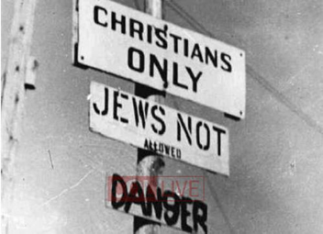  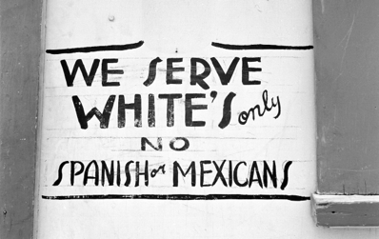  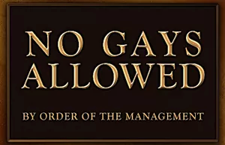  3. Homework #1:  The teacher will give students a recent photo that displays discrimination and make them find a photo that compares on the Centropa website.  3. Instruction:  (35 minutes) Teacher and students will have a discussion about the photos from homework. Teacher will show “Return to Rivne” from the Centropa website. The teacher and students will discuss the importance of recognizing upstanders in times of discriminations. The teacher will show the video “Who Is An Upstander?” by Facing History and then discuss what an upstander is.  Discussion questions -  What separates an upstander from an average civilian?  Do you have to be extraordinary to be an upstander?  Would you have the courage to be an upstander?  How do we convince more people to be upstanders?  Who has been an upstander in your life?  Why is it important to recognize the upstanders?  4. Independent Work:  Students will find an upstander from their country or the world on their own and do a project/paper on them. The teacher can have them find their own or choose from the list provided.  The project you choose will determine the length of the project.  Ideas for Project:  i. Newspaper Article – 2 to 3 days  ii. Short Biography – 2 to 3 days  iii. Powerpoint Presentation – 1 week  iv. Multi-page Research Paper – 2 to 3 weeks  v. Centropa style video - 4 to 5 weeks  5. Global Learning:  (60 minutes) Students will exchange projects (or present them on Skype) to students in another country. We can be a role model of breaking down discrimination and borders by exposing them to another culture.  6. Homework #2:  Students will reflect on what they learned. They will write a reflection about how to prevent this from happening and what discrimination is like in their life/community and how it compares to the rest of the world.  7. Closure:  (20 minutes) Discussion after homework is turned in on how to prevent discrimination and what discrimination looks like in their life/community and how it compares to the rest of the world.
Additional Ideas | Marketplace of Ideas:  (60 minutes) Teachers in nearby countries (i.e. Europe) can do a conference Skype session where one student presents their project and classes are watching and listening from around the world. Afterwards, there will be a panel-like discussion with the classrooms.

