“CHILDREN AMONG THE NATIONS”
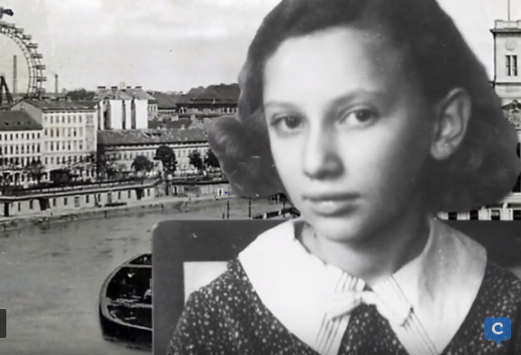

Overview information
Lesson plan title: Children among the Nations
Teacher(s): Teaching the Holocaust in the 21st Century elective subgroup members: Marina Anghel, Irit Aviad, Evgenia Doulami, Roy Nissim, Justin Pohlmann
Type of school: General Education
Subjects taught: Language, Literature/Creative writing, History, Civic Education, Geography, English as a second language, Jewish culture, Art
Primary category: Kindertransport
Grade level of students: Adapted version is usable for both primary school students and high school students
Total required time for teaching the lesson: Up to 2 months depending on grade level

Summary:
This lesson plan was created during CSA 2018 as a part of the small group work of the Teaching the Holocaust in the 21st Century Elective group. The main aim of the lesson plan is that students develop an understanding of the notion of “Kindertransport.” They will research about the Kindertransport through a variety of Centropa films and bios along with other resources. Eventually, they will demonstrate their knowledge to the class through several different tasks. (map/timeline etc.)

Background information:
Build knowledge through Centropa’s film of Lili Tauber “A Suitcase full of Memories” and Kindersport.

Enduring Understanding:
Basic Aim:
→ To mobilize the interest and the feelings of the pupils about Kindertransport
Goals/Objectives:
Goals/Objectives:
The students will be able to:
→ focus on personal stories by watching videos & reading biographies
→ understand the value of helping each other
→ have empathy towards others
→ understand the importance of civic society in times of crisis

Resources: Photos of Kindertransport
Centropa bios- http://www.centropa.org/biography/hannah-fischer
http://www.centropa.org/biography/kitty-suschny

Centropa Video- http://www.centropa.org/centropa-cinema/lilli-tauber- suitcase-full-memories?language=en

The lesson:
Introduction to the Unit (45 min)
Students discuss answers with partners or whole group
- What will I put in my suitcase?
- Where will I go with my suitcase?
- With whom will I go?
- When will I go?
- Here is my suitcase –
Students will create a folder/drawing and put items in
their suitcase that mean the most to them

Activity 1 (45 min):
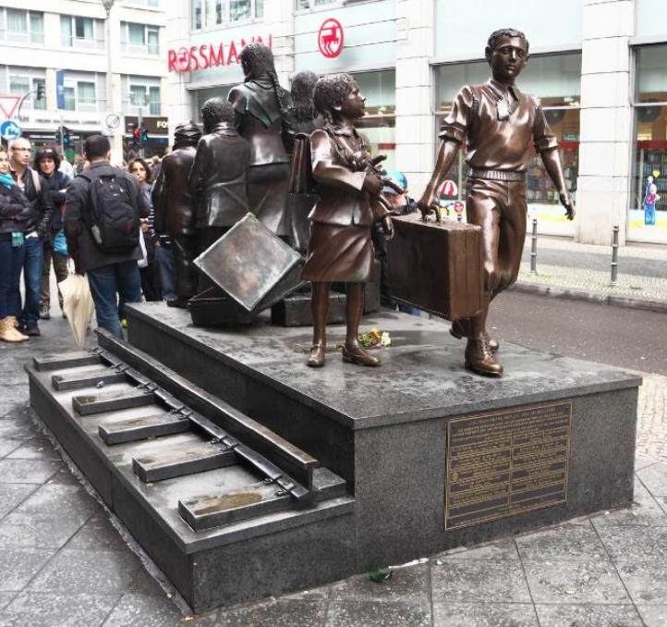
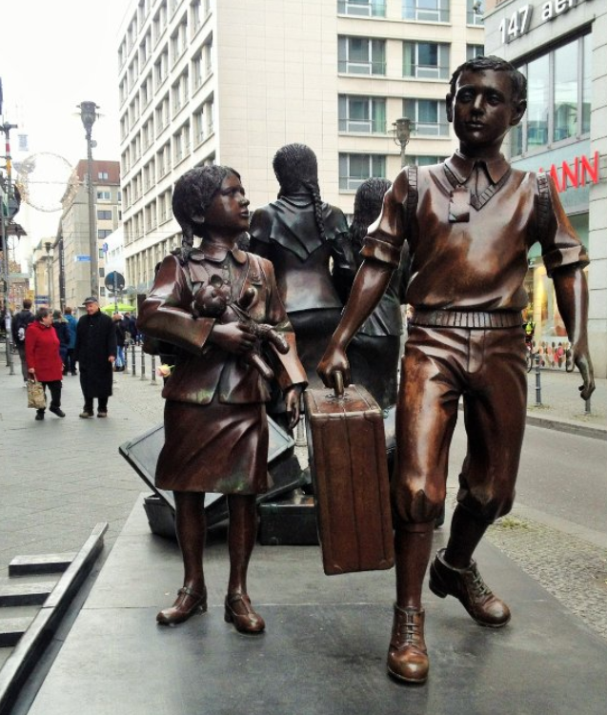
Students will analyze the pictures of the statues and answer the following questions and discuss with the class
Look at the pictures -
- Where are they?
- How many kids do you see?
- What do they hold?
- Where are they going?
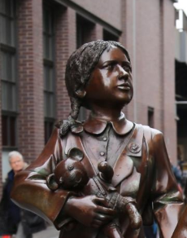
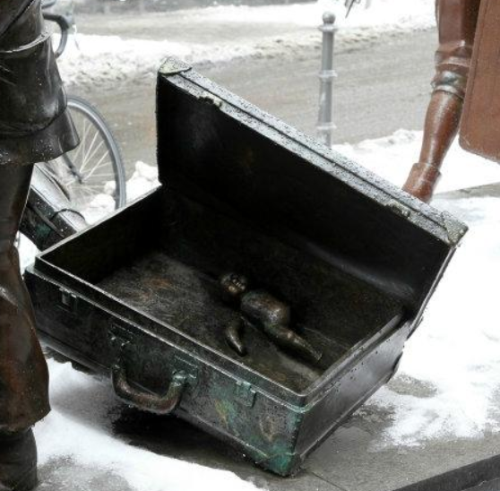
- How do they look like?
- How do they dress?
- What do their faces look like?
- How do you think that they feel?

Activity 2 (45 min):
Background Knowledge on Kindertransport
- Students and teachers will read a brief history/background on Kindertransport
- Depending on grade level you teach, teacher will find an appropriate reading to support the history of Kindertransport

Main part (60 min)
The story of Lili Tauber “A Suitcase full of Memories”
The teacher briefly introduces the Centropa film from the link below. While watching the film students will participate in a “While you watch task” (varies upon grade level)
http://www.centropa.org/centropa-cinema/lilli-tauber-suitcase-full-memories?language=en
Group Activity (90 min)
Students will be divided into groups, each group will have different biography to read from Centropa website. The teacher will provide the links to the bios. Each participant in the group will follow one activity.
Task 1- Timeline
This group will create a timeline of the selected biography
Task 2- Language Skills
This group will write a summary of the story of the selected biography
Task 3- Geography
Create a map of the route of the child according to the biography they read
Task 4- Art
Create/draw/images that represents the bio that they have chosen

Homework assignment:
Finish their individual task from their group.

Conclusion:
Groups will present to the class the final product of the bio that they researched. Making sure to include the map route, timeline, summary and art work of the bio.

